Aim: Implement the Diffie-Hellman key exchange algorithm to securely exchange keys
between two entities over an insecure network.
CLI:

# Diffie-Hellman Key Exchange
# Educational implementation

# Public parameters
p = 23
g = 5

# Private keys (kept secret)
alice_private = 6
bob_private = 15

# Public keys
alice_public = pow(g, alice_private, p)
bob_public = pow(g, bob_private, p)

print("Alice's public key:", alice_public)
print("Bob's public key:", bob_public)

# Each party calculates the shared secret
alice_shared_secret = pow(bob_public, alice_private, p)
bob_shared_secret = pow(alice_public, bob_private, p)

print("Alice's shared secret:", alice_shared_secret)
print("Bob's shared secret:", bob_shared_secret)

# Verify that both calculated the same secret
if alice_shared_secret == bob_shared_secret:
print("Key exchange successful!")
print("Shared secret:", alice_shared_secret)
else:
print("Key exchange failed!")

Output:
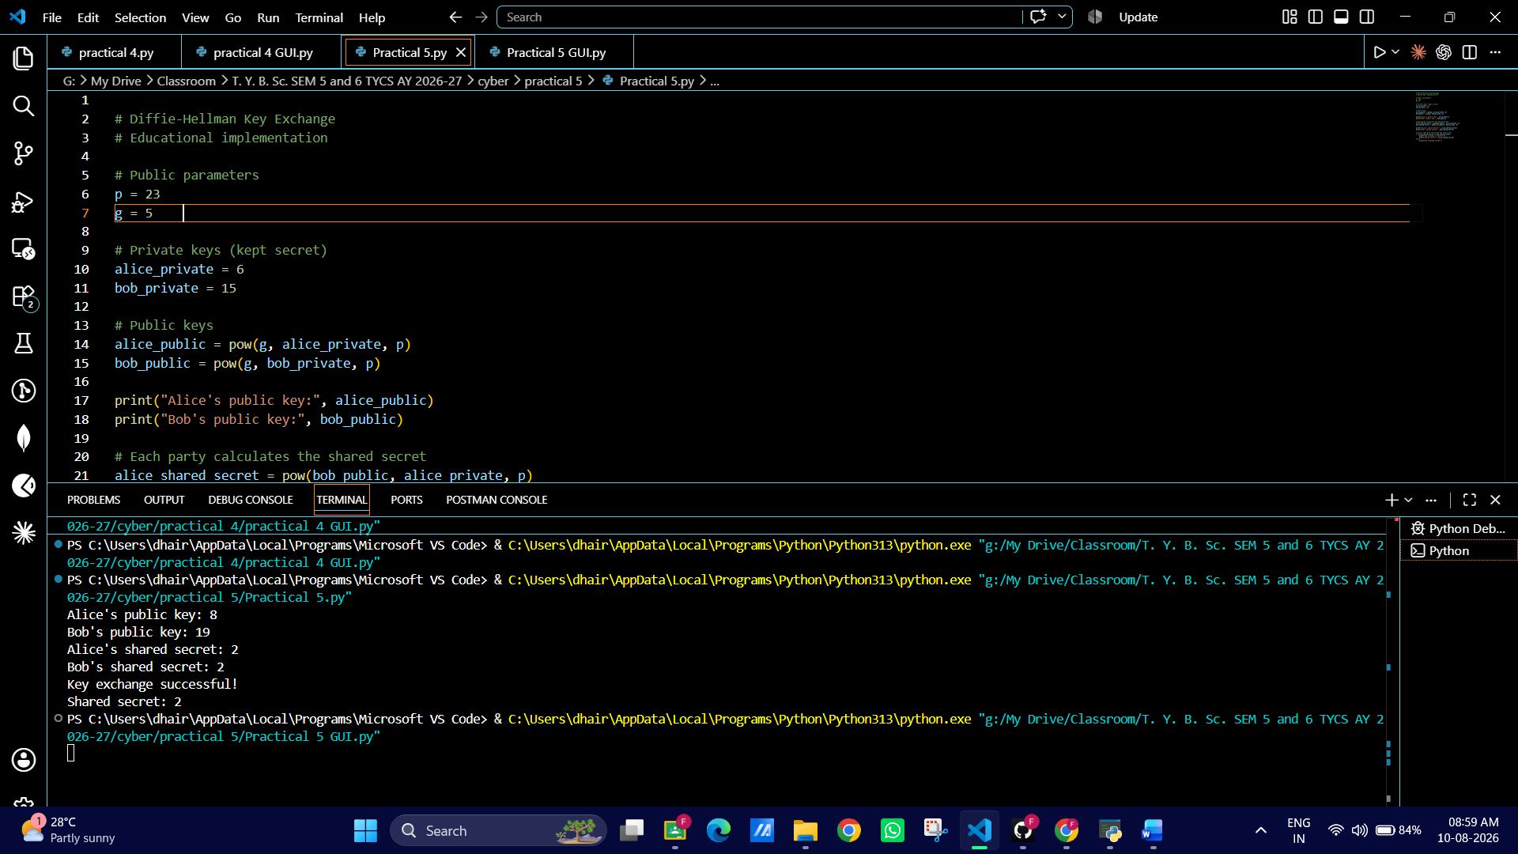

GUI:
import tkinter as tk
from tkinter import messagebox

def perform_diffie_hellman():
try:
# Get values from GUI
p = int(p_entry.get())
g = int(g_entry.get())
alice_private = int(alice_entry.get())
bob_private = int(bob_entry.get())

# Basic validation
if p <= 1:
raise ValueError("p must be greater than 1.")

if g <= 0:
raise ValueError("g must be positive.")

if alice_private <= 0 or bob_private <= 0:
raise ValueError("Private keys must be positive.")

# Calculate public keys
alice_public = pow(g, alice_private, p)
bob_public = pow(g, bob_private, p)

# Calculate shared secret
alice_shared = pow(bob_public, alice_private, p)
bob_shared = pow(alice_public, bob_private, p)

# Display results
alice_public_result.config(text=str(alice_public))
bob_public_result.config(text=str(bob_public))
alice_shared_result.config(text=str(alice_shared))
bob_shared_result.config(text=str(bob_shared))

if alice_shared == bob_shared:
status_label.config(
text="✓ Key Exchange Successful!",
fg="green"
)
else:
status_label.config(
text="✗ Key Exchange Failed!",
fg="red"
)

except ValueError as e:
messagebox.showerror("Invalid Input", str(e))

def clear_fields():
p_entry.delete(0, tk.END)
g_entry.delete(0, tk.END)
alice_entry.delete(0, tk.END)
bob_entry.delete(0, tk.END)

alice_public_result.config(text="-")
bob_public_result.config(text="-")
alice_shared_result.config(text="-")
bob_shared_result.config(text="-")

status_label.config(text="")

# ---------------- GUI ----------------

root = tk.Tk()
root.title("Diffie-Hellman Key Exchange")
root.geometry("600x600")
root.resizable(False, False)
root.configure(bg="#f2f2f2")

# Title
title = tk.Label(
root,
text="Diffie-Hellman Key Exchange",
font=("Arial", 22, "bold"),
bg="#f2f2f2",
fg="#1f3c88"
)
title.pack(pady=20)

subtitle = tk.Label(
root,
text="Secure key exchange demonstration",
font=("Arial", 11),
bg="#f2f2f2",
fg="#555555"
)
subtitle.pack()

# Input frame
input_frame = tk.Frame(root, bg="white", padx=20, pady=20)
input_frame.pack(pady=20)

# Public parameters
tk.Label(
input_frame,
text="Public Parameters",
font=("Arial", 14, "bold"),
bg="white"
).grid(row=0, column=0, columnspan=2, pady=10)

tk.Label(
input_frame,
text="Prime number (p):",
font=("Arial", 11),
bg="white"
).grid(row=1, column=0, sticky="w", pady=7)

p_entry = tk.Entry(input_frame, width=25, font=("Arial", 11))
p_entry.grid(row=1, column=1, pady=7)

tk.Label(
input_frame,
text="Generator (g):",
font=("Arial", 11),
bg="white"
).grid(row=2, column=0, sticky="w", pady=7)

g_entry = tk.Entry(input_frame, width=25, font=("Arial", 11))
g_entry.grid(row=2, column=1, pady=7)

# Private keys
tk.Label(
input_frame,
text="Private Keys",
font=("Arial", 14, "bold"),
bg="white"
).grid(row=3, column=0, columnspan=2, pady=(15, 10))

tk.Label(
input_frame,
text="Alice's private key:",
font=("Arial", 11),
bg="white"
).grid(row=4, column=0, sticky="w", pady=7)

alice_entry = tk.Entry(input_frame, width=25, font=("Arial", 11))
alice_entry.grid(row=4, column=1, pady=7)

tk.Label(
input_frame,
text="Bob's private key:",
font=("Arial", 11),
bg="white"
).grid(row=5, column=0, sticky="w", pady=7)

bob_entry = tk.Entry(input_frame, width=25, font=("Arial", 11))
bob_entry.grid(row=5, column=1, pady=7)

# Buttons
button_frame = tk.Frame(root, bg="#f2f2f2")
button_frame.pack(pady=5)

calculate_button = tk.Button(
button_frame,
text="Calculate Shared Key",
command=perform_diffie_hellman,
bg="#1f6feb",
fg="white",
font=("Arial", 11, "bold"),
padx=15,
pady=8
)
calculate_button.grid(row=0, column=0, padx=10)

clear_button = tk.Button(
button_frame,
text="Clear",
command=clear_fields,
bg="#555555",
fg="white",
font=("Arial", 11, "bold"),
padx=25,
pady=8
)
clear_button.grid(row=0, column=1, padx=10)

# Results
result_frame = tk.Frame(root, bg="white", padx=25, pady=15)
result_frame.pack(pady=15)

tk.Label(
result_frame,
text="Results",
font=("Arial", 14, "bold"),
bg="white"
).grid(row=0, column=0, columnspan=2, pady=5)

tk.Label(
result_frame,
text="Alice's Public Key:",
font=("Arial", 11),
bg="white"
).grid(row=1, column=0, sticky="w", pady=5)

alice_public_result = tk.Label(
result_frame,
text="-",
font=("Arial", 11, "bold"),
bg="white",
fg="#1f3c88"
)
alice_public_result.grid(row=1, column=1, sticky="w", padx=20)

tk.Label(
result_frame,
text="Bob's Public Key:",
font=("Arial", 11),
bg="white"
).grid(row=2, column=0, sticky="w", pady=5)

bob_public_result = tk.Label(
result_frame,
text="-",
font=("Arial", 11, "bold"),
bg="white",
fg="#1f3c88"
)
bob_public_result.grid(row=2, column=1, sticky="w", padx=20)

tk.Label(
result_frame,
text="Alice's Shared Secret:",
font=("Arial", 11),
bg="white"
).grid(row=3, column=0, sticky="w", pady=5)

alice_shared_result = tk.Label(
result_frame,
text="-",
font=("Arial", 11, "bold"),
bg="white",
fg="#8a2be2"
)
alice_shared_result.grid(row=3, column=1, sticky="w", padx=20)

tk.Label(
result_frame,
text="Bob's Shared Secret:",
font=("Arial", 11),
bg="white"
).grid(row=4, column=0, sticky="w", pady=5)

bob_shared_result = tk.Label(
result_frame,
text="-",
font=("Arial", 11, "bold"),
bg="white",
fg="#8a2be2"
)
bob_shared_result.grid(row=4, column=1, sticky="w", padx=20)

# Status
status_label = tk.Label(
root,
text="",
font=("Arial", 13, "bold"),
bg="#f2f2f2"
)
status_label.pack(pady=10)

root.mainloop()
Output:
